Instructor: Desmond Kwan
CH222
Exam 3A
Name: (Print)_________________________________________________

Multiple choices (100 pts): Each question has only one correct answer. Mark your answer on a scantron sheet. Only seventeen out of twenty five questions will counted.
1. Which of these compounds are aromatic?
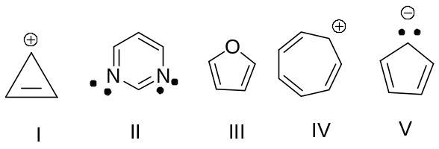

(a) I, II, and III (b) I, III, and IV (c) I, III, and V (d) I, II, III, IV, and V (e) none of these answers

2. What would be the rearrangement product of this reaction?
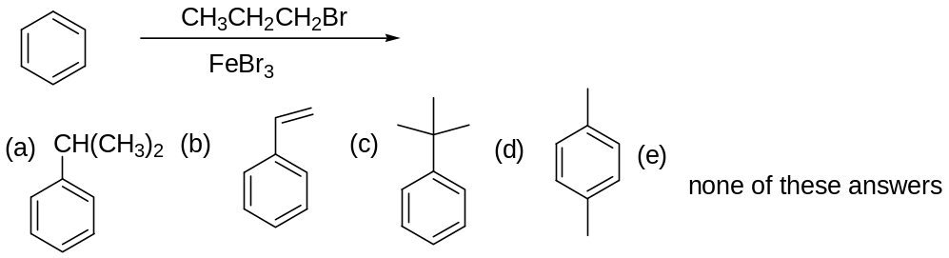

3. Which is the weakest acid?
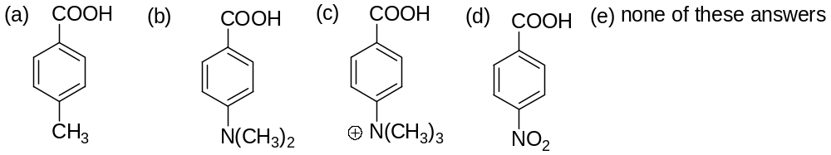

4. Which is the weakest base?

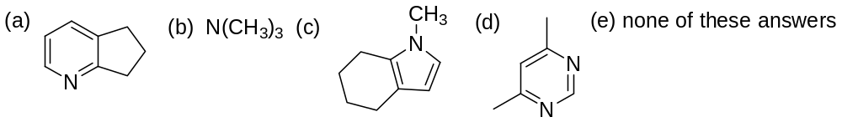

5. Which would be the major product(s) of this reaction?

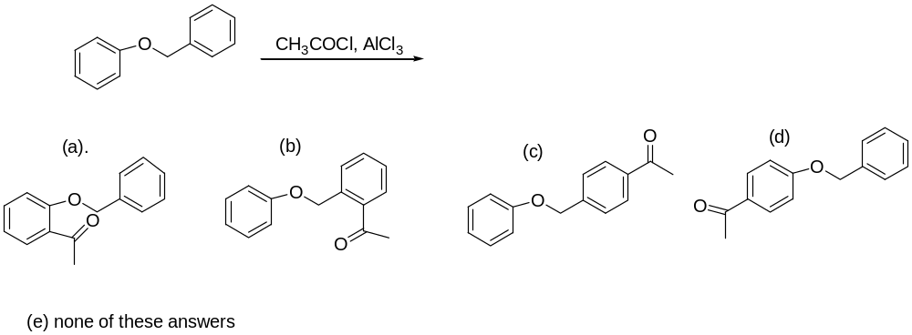
6. Which would be the major product(s) of this reaction?
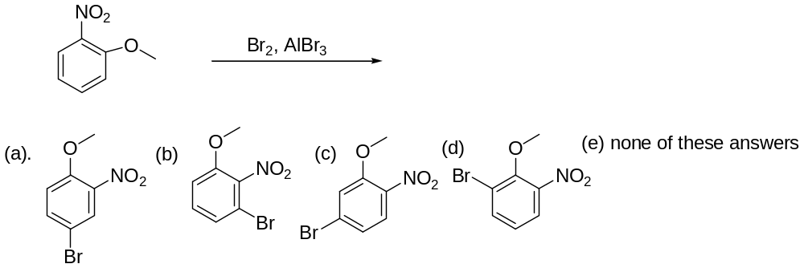

7. Which would be the major organic product of this reaction?
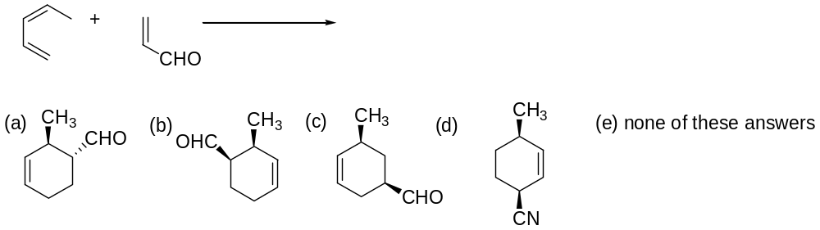

8. Which would be the major organic product of this reaction?

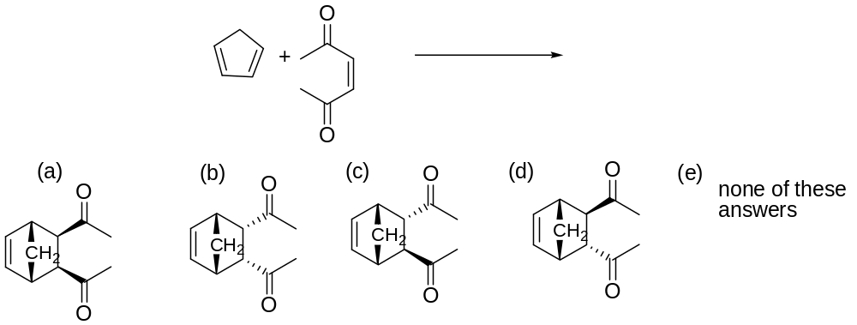

9. Which would be the major organic product of this multi-synthesis?
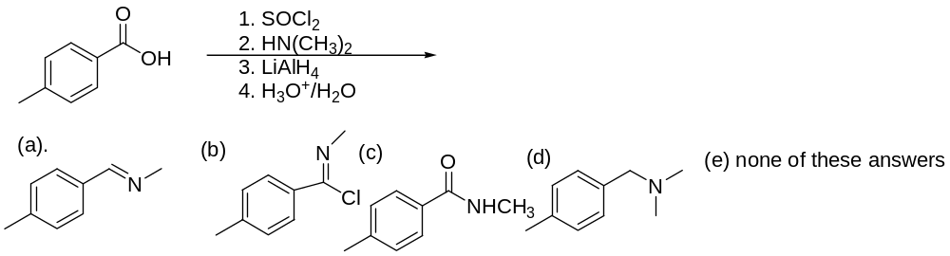

10. Which would be the major organic product of this reaction?
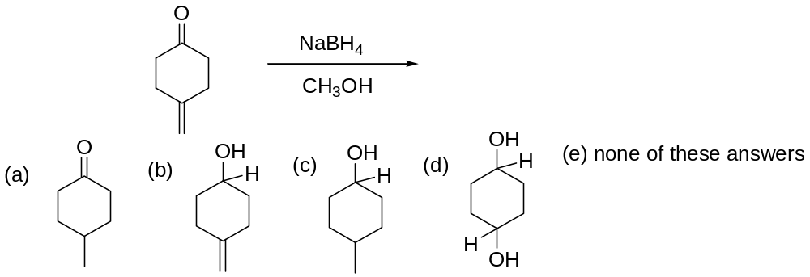

11. Which would be the major organic product of this reaction?

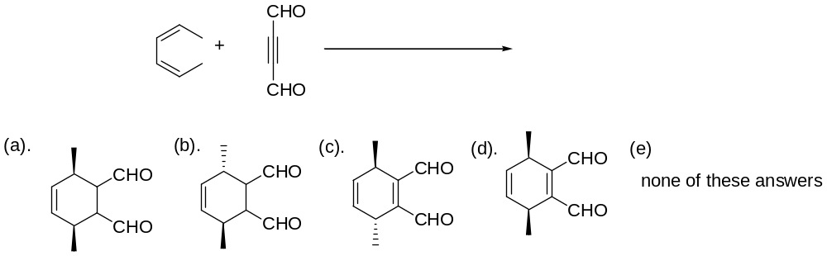

12. Which would be the major organic product of this reaction?
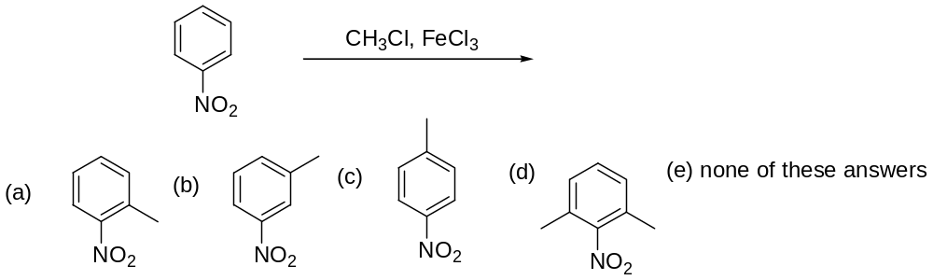

13. Which would be the major organic product of this reaction?
. 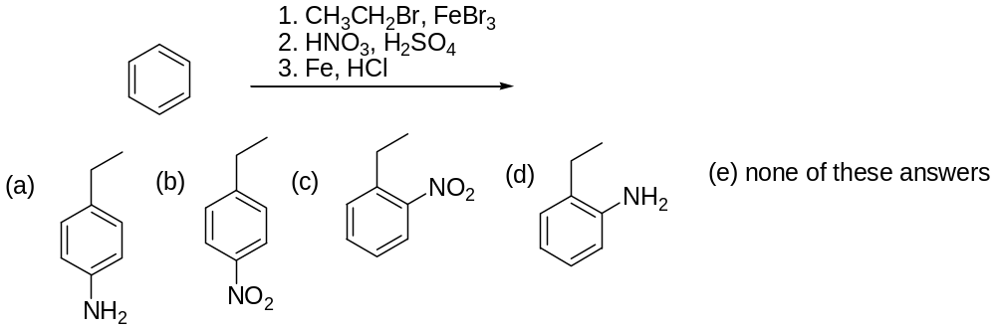

14. Which would be the major organic product of this reaction?
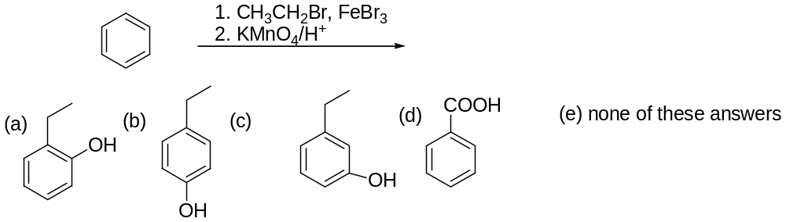

15. Which would be the major organic product of this reaction?
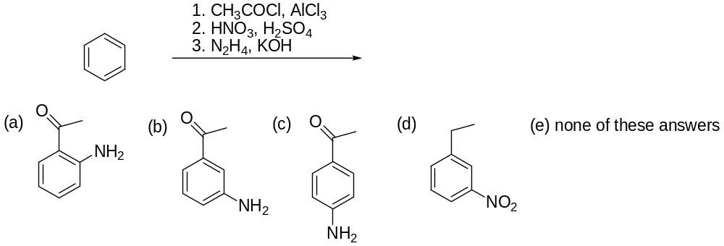

16. Which would be the major organic product of this reaction?

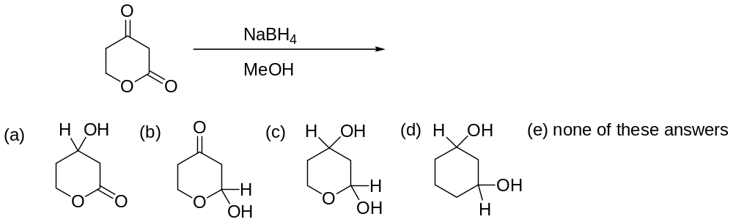

17. Which would be the major organic product of this reaction?

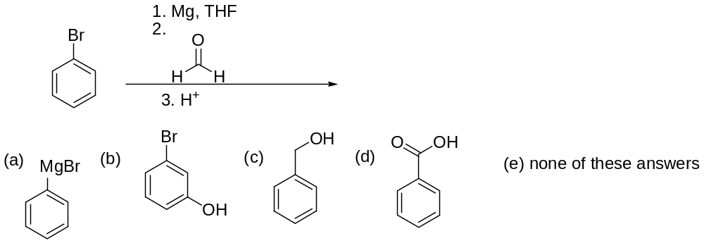

18. What is the major product of this reaction?
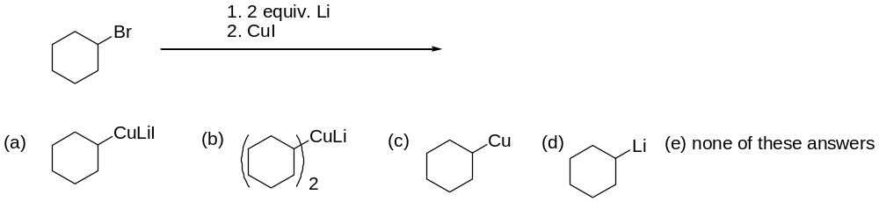

19. Which would be the major organic product of this reaction?

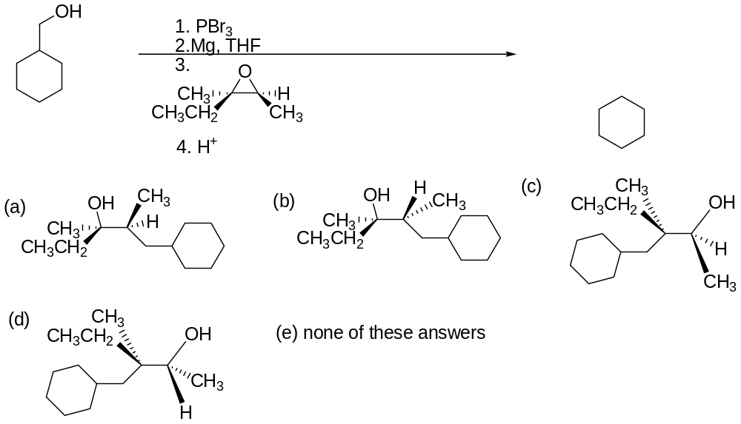

20. Which reagent or set of reagents will best used for producing the synthetic target shown?
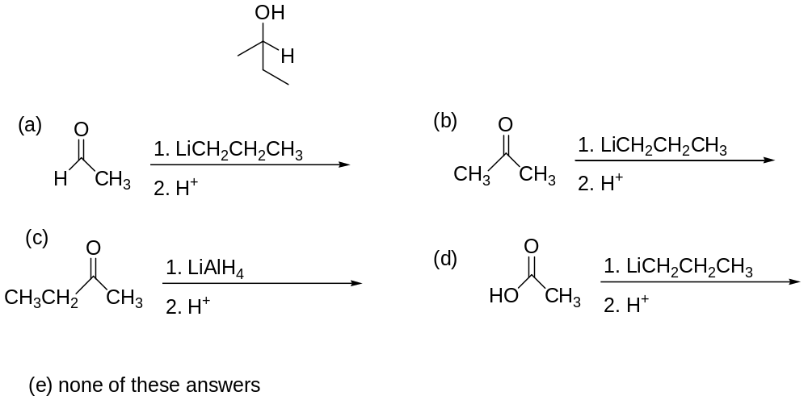

21. Predict the major organic product for the reaction shown below:
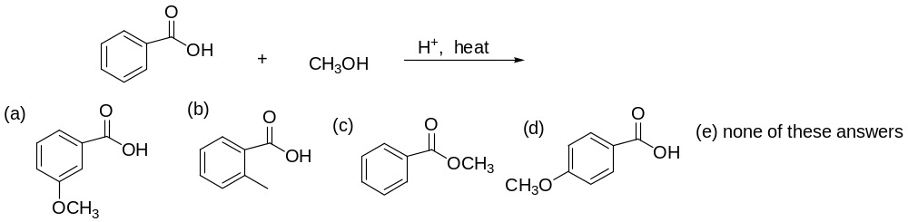

22. Which structure is consistent with this ¹H NMR spectrum?
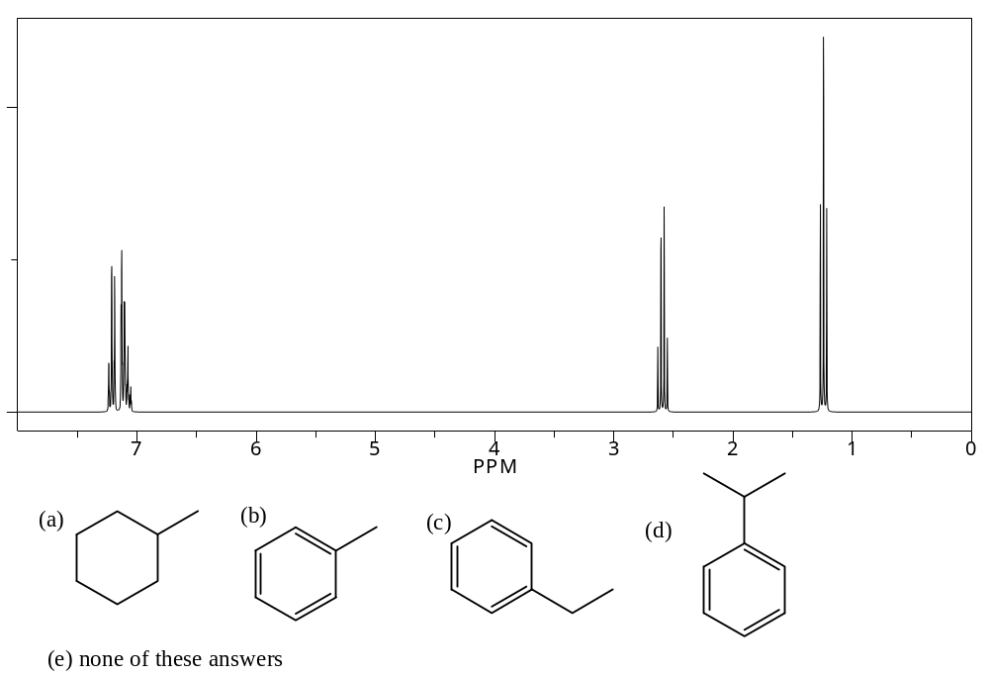

23. Which would be the major organic product of this reaction?
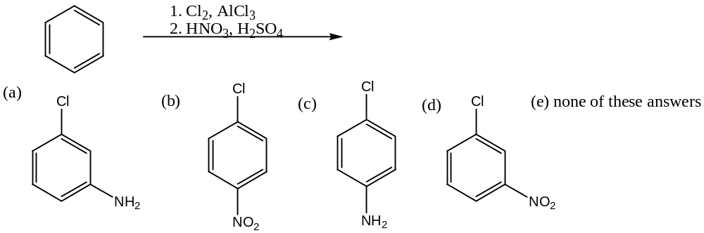

24. Which would be the major organic product of this reaction?
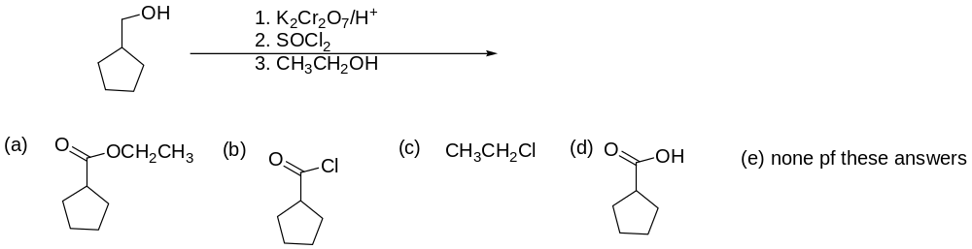

25. Which would be the major organic product of this reaction?


